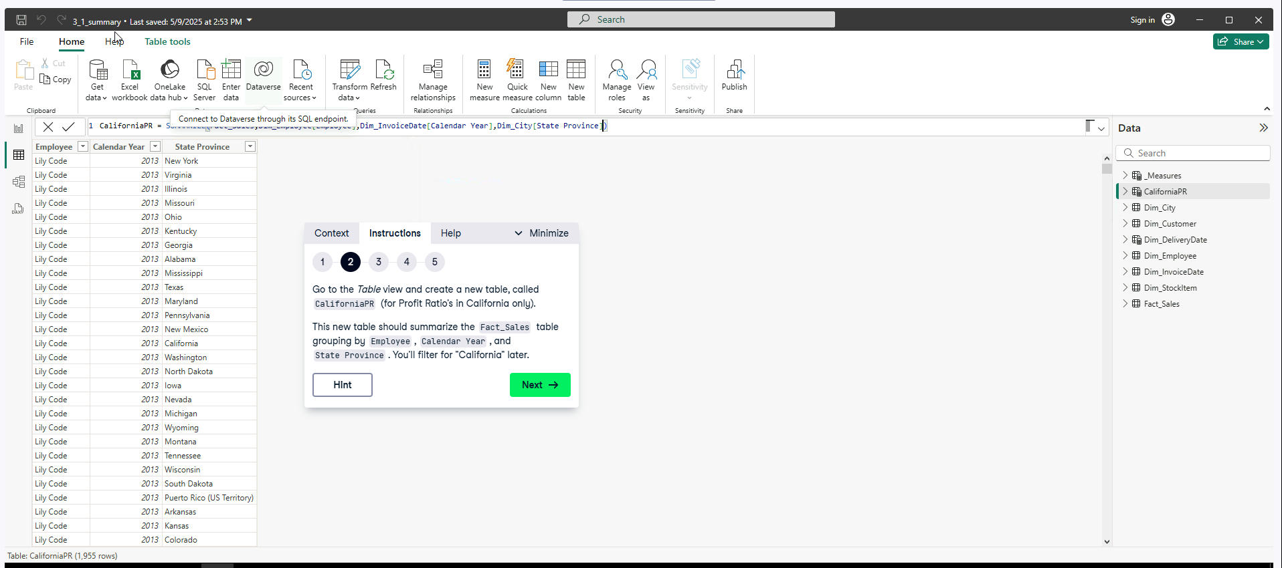**Data Analyst in Power BI Data-Camp 2025**

**Section 11: Intermediate DAX in Power BI**

1. **Logical Functions**

**Exercise 1.1**

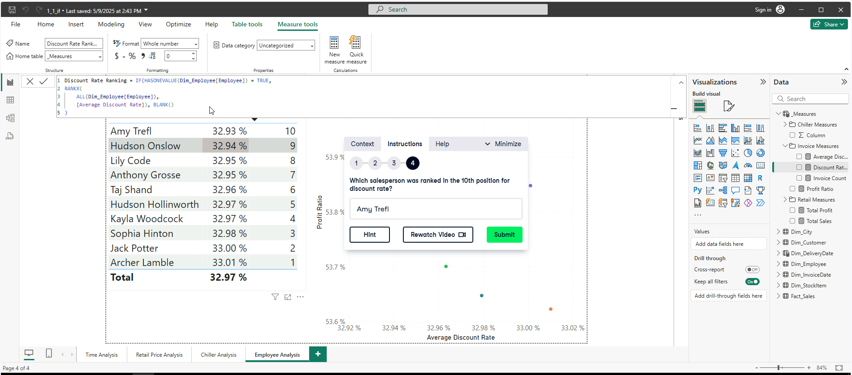

Dax Measure IF(), to evaluate if a row of an employee has only one value. If the value is TRUE, then utilize the RANKX(), if false returns blank.

Applying the SWITCH(TRUE,…) statement along with AND() statements.

**Exercise 1.3**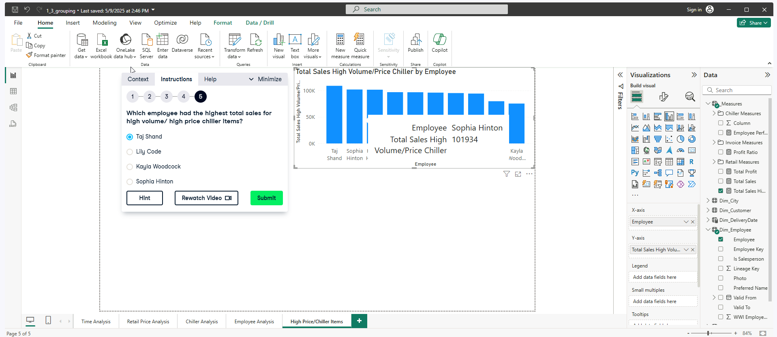**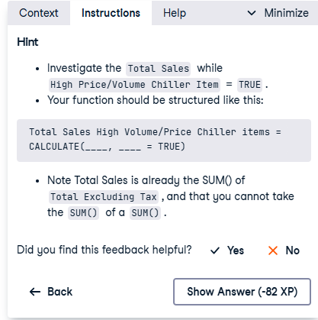

DAX Measure High Volume/Volume Chiller Items 

1. **Row-level Security A screenshot of a computer

   AI-generated content may be incorrect.**

**Exercise 2.1**

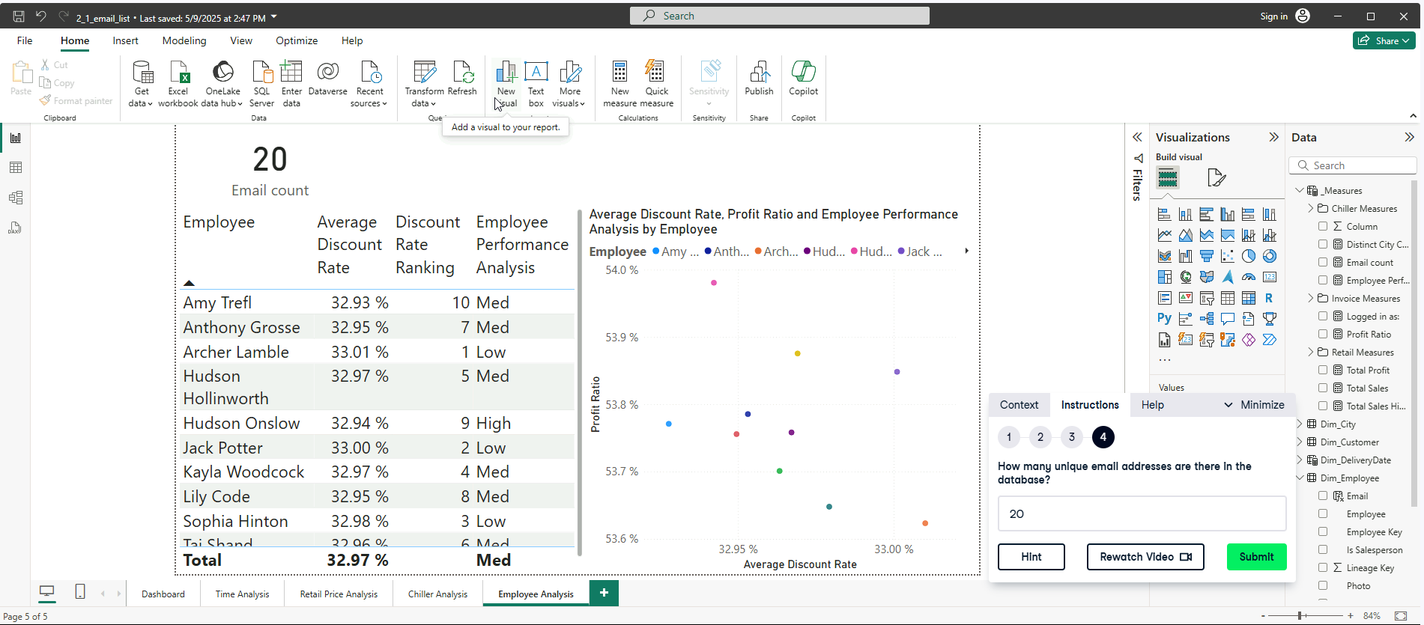

**Calculated column for Email,**

Email = LOWER(SUBSTITUTE(Dim_Employee[Employee],” “,”.”)& “@wwi.com”)

**EMAIL COUNT DAX MEASURE,**

Email count = DISTINCTCOUNT(Dim_Employee[Email])

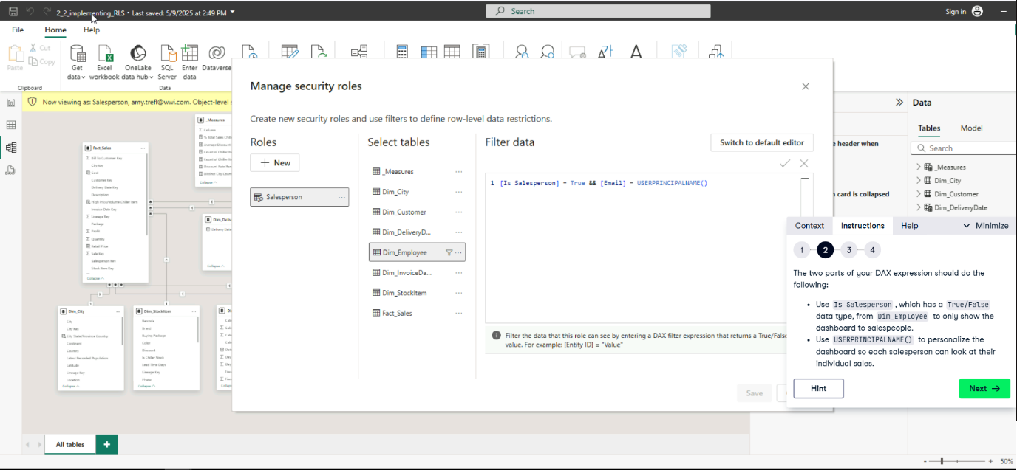

**Exercise 2.3**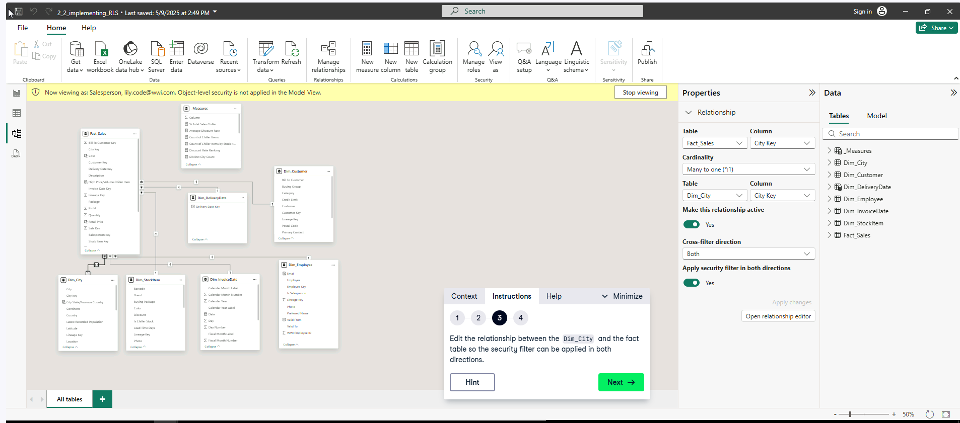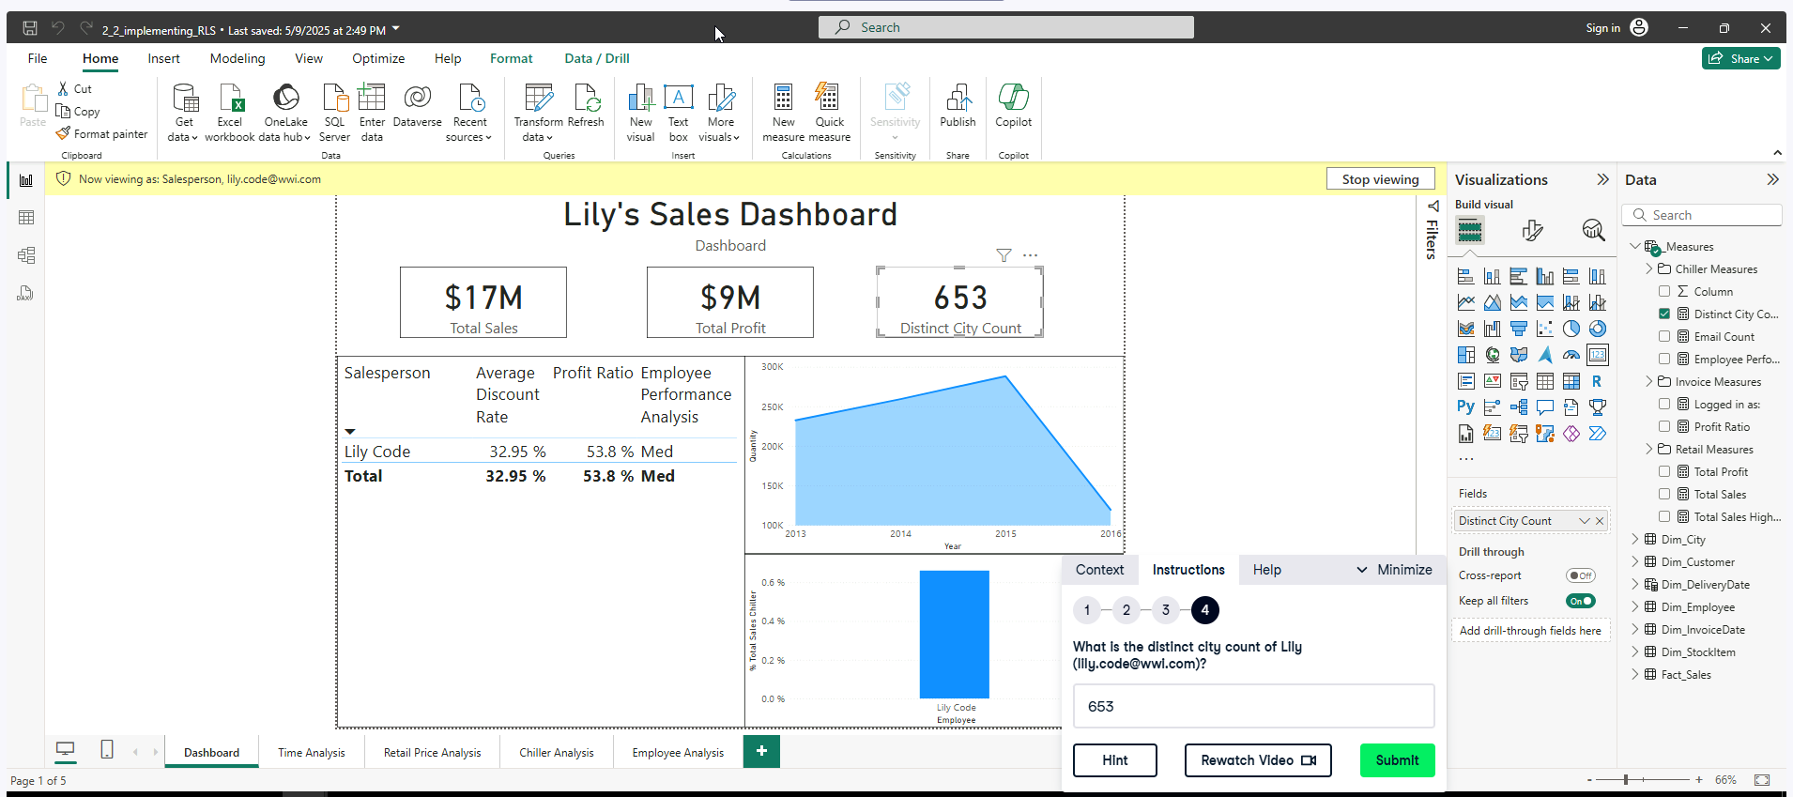

**Table Manipulation Functions**

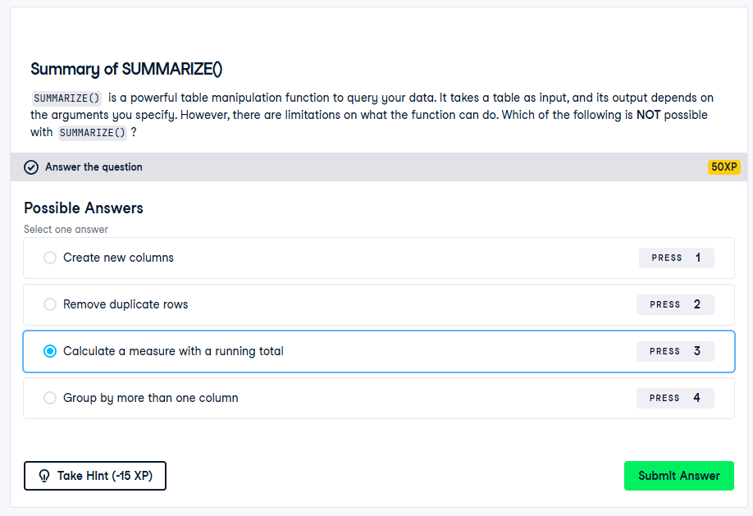

**Exercise 3.1**

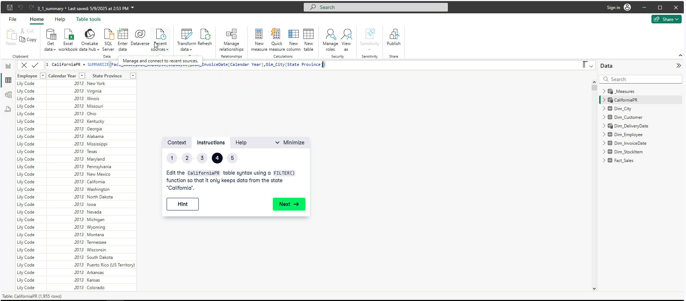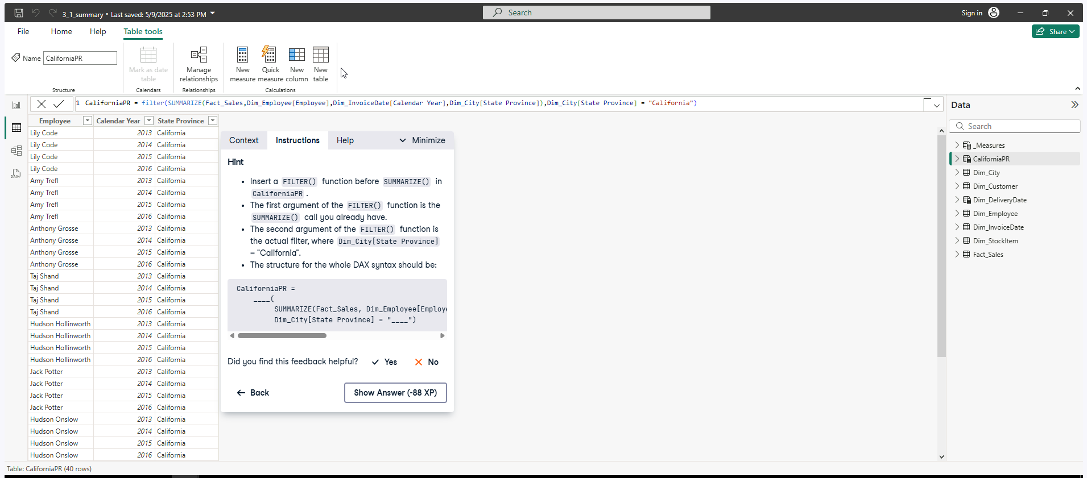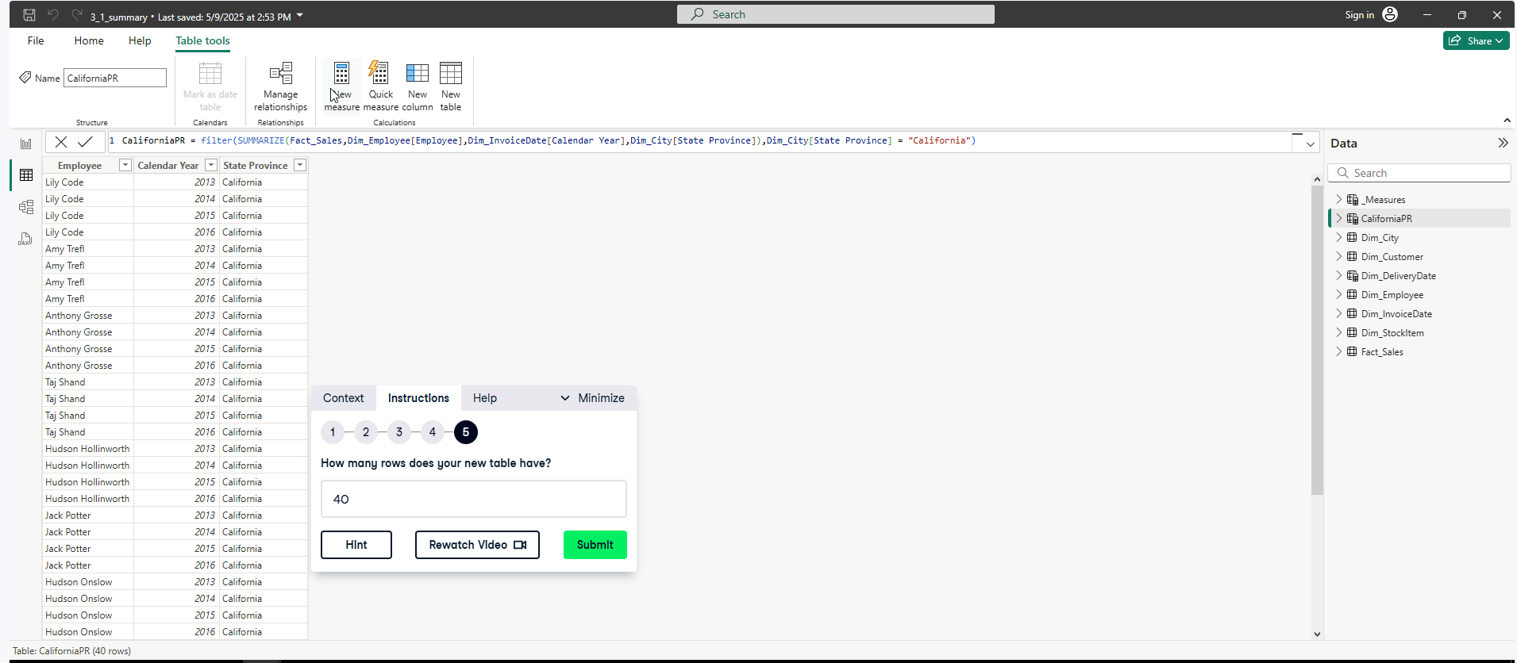

**Exercise 3.2**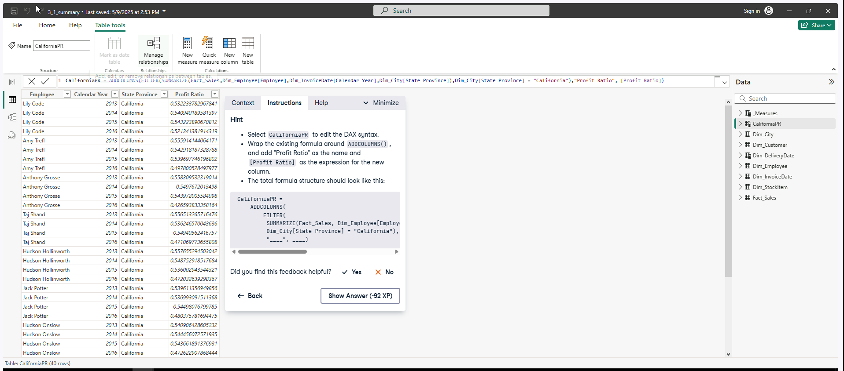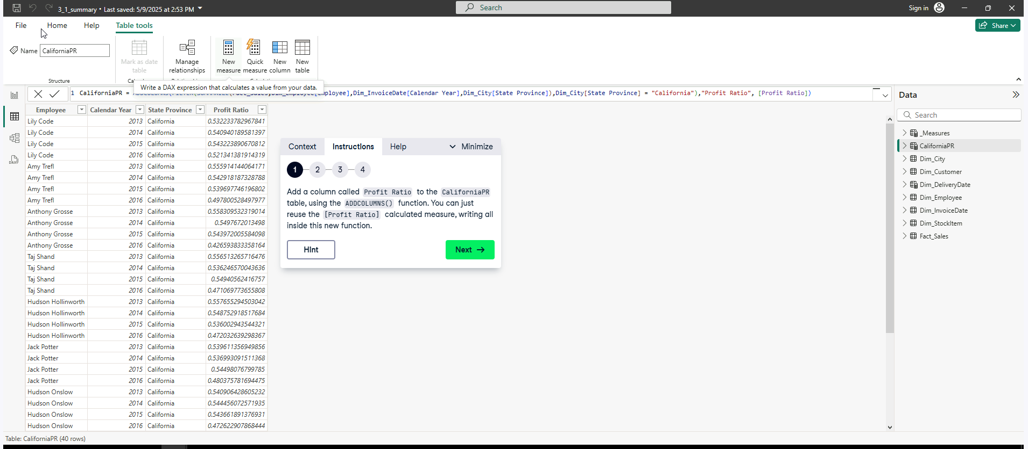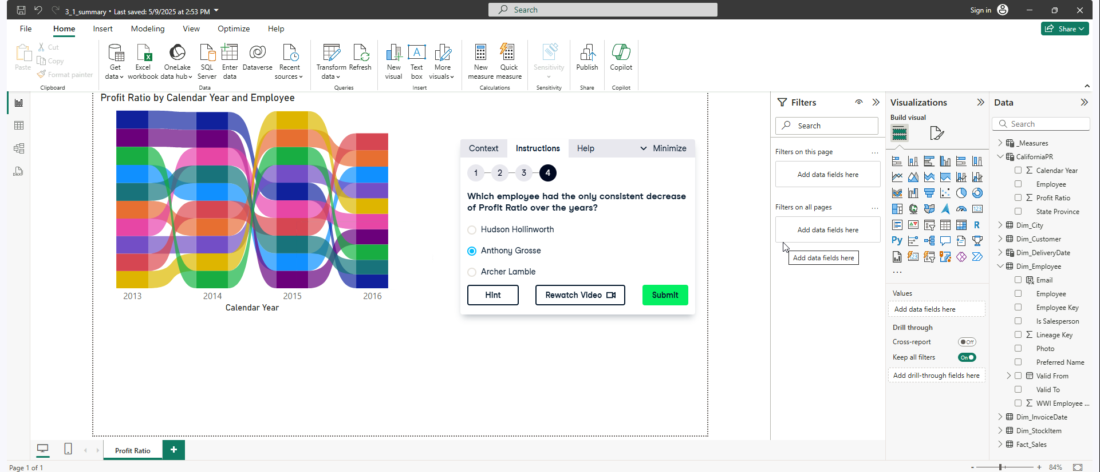

**Time Intelligence Functions**

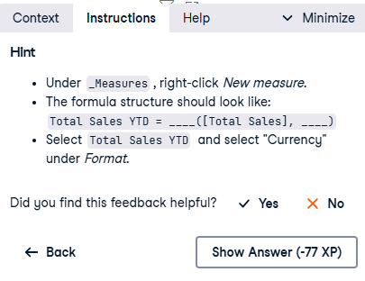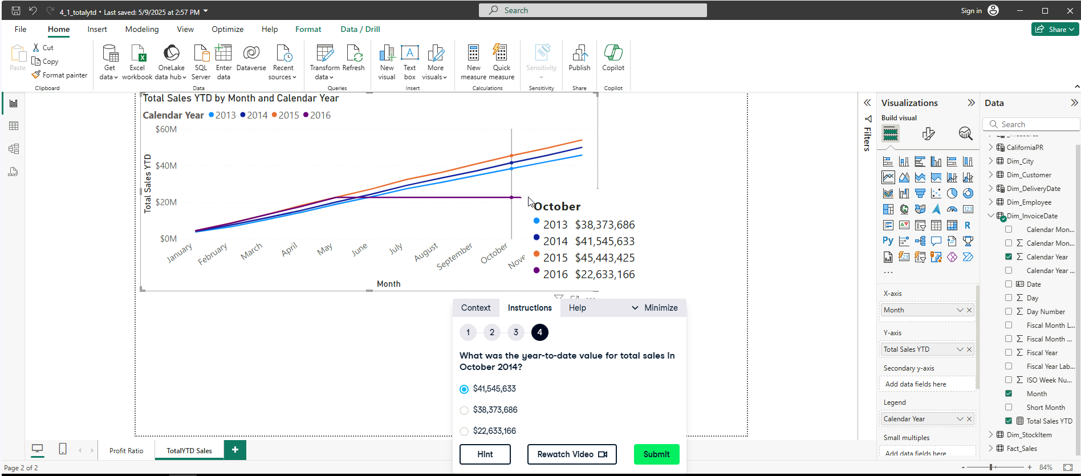

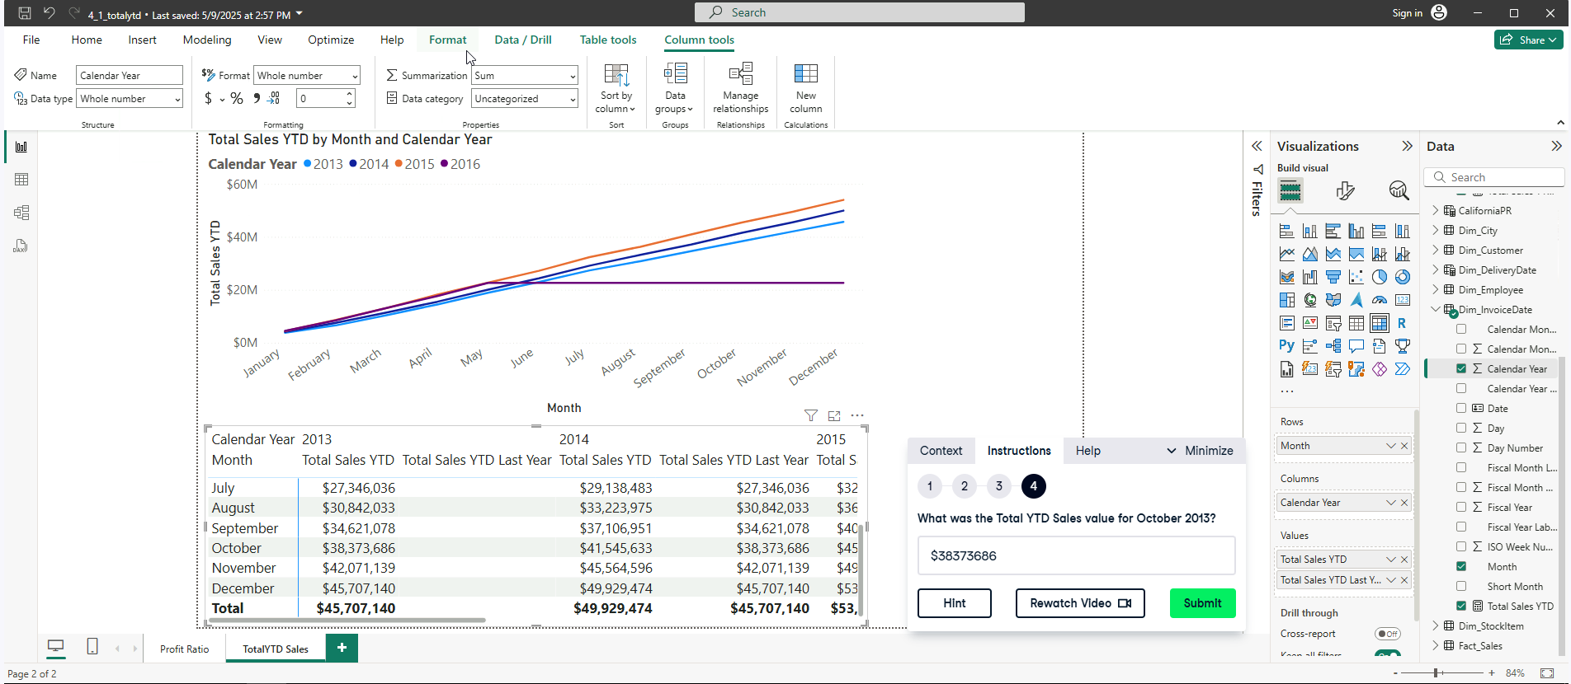

**Exercise 4.3**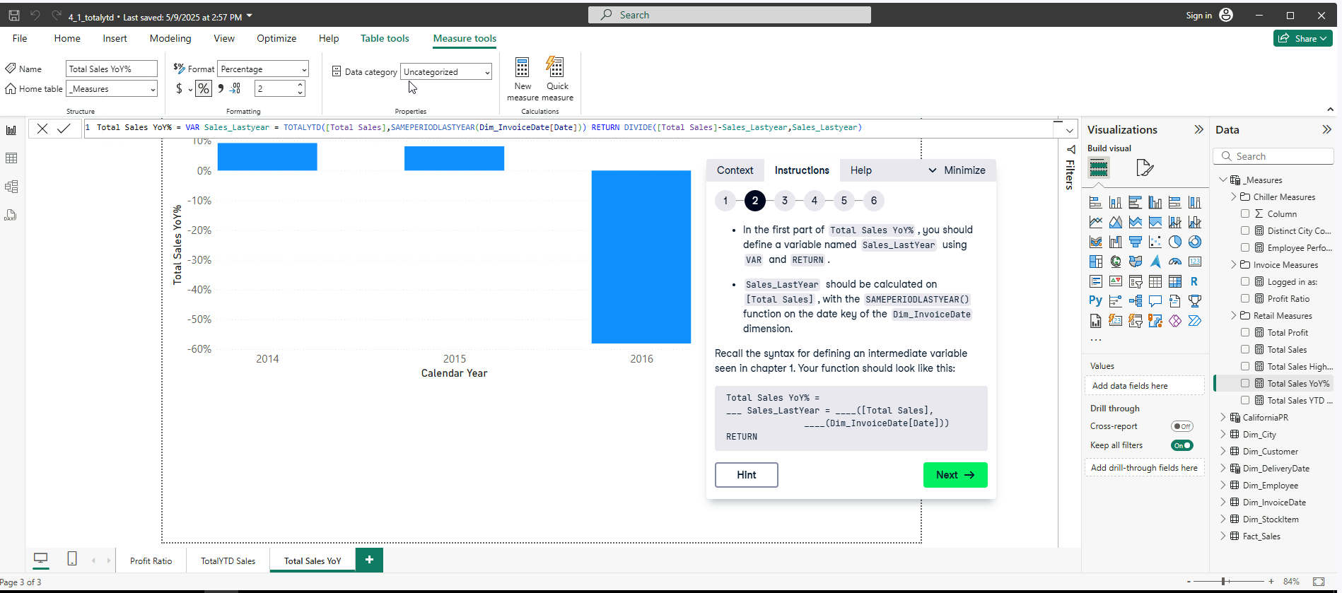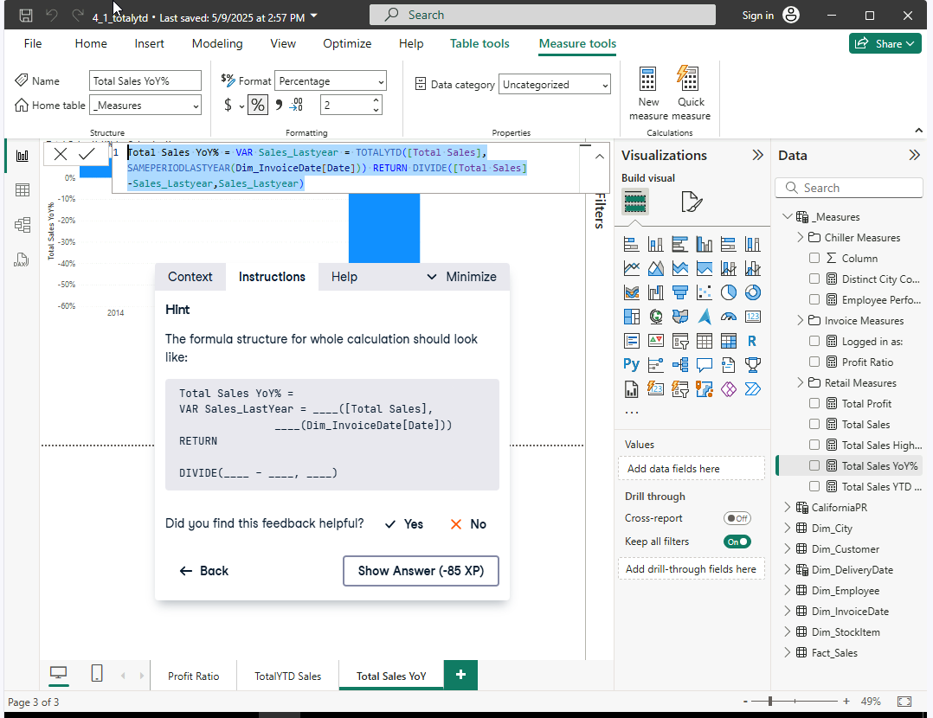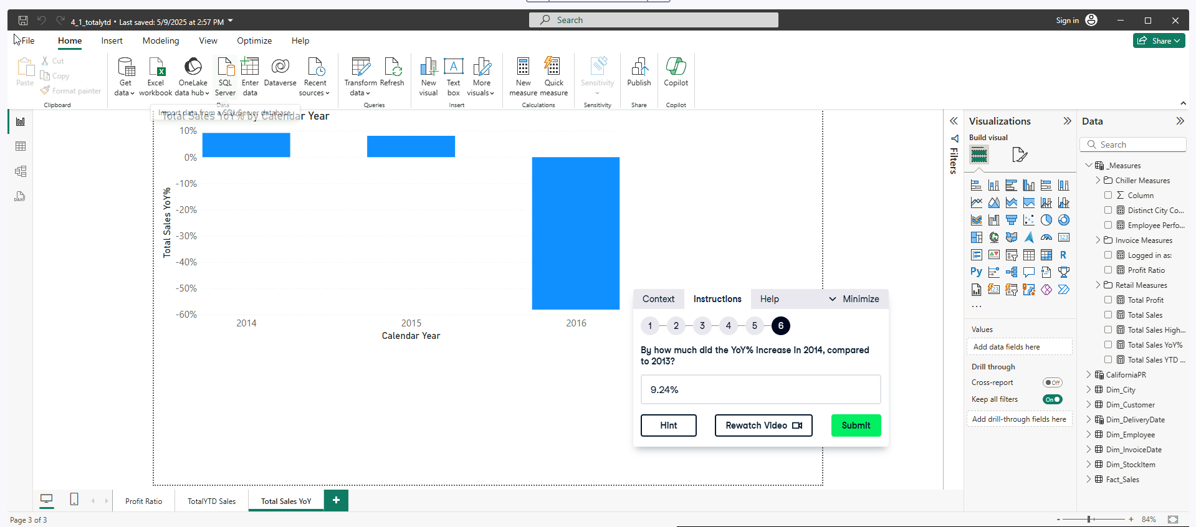

**Exercise 4.4**

**My attempt Q and A to Visual** 